The bending stiffness of *N*-layer laminated cylinders is

 (1)

where  and  are the internal and external radii of each layer, respectively, , as shown in figure 1,  is constant, are the compliance constants, and for each layer we have

 (2)

with

 (3)



Figure 1: Schematic of *N*-layer laminated cylinders with radius sequence {*b*n}

**To simplify the problem, let us assume that elastic constants are the same for each layer.** Then the bending stiffness is expressed as

 (4)

with coefficients

 (5)

**Part I: No-friction interface**

In the case of frictionless interface, the 5*N* unknown constants (4*N* *Ki*’s and *N* *v*’s) are determined as following. The *N*-1 interfacial conditions result in 5(*N*-1) equations

 (6)

*n* = 1, 2, …, *N*-1, while the inner and outer free surface conditions yield four more equations

 (7)

With the known equation , we have 5*N* equations to solve for the 5*N* unknowns. Especially, the 4*N* unknowns  can be obtained by solving the following linear equations

 (8)

Let (*b0* and *bN* are the inner and outer radius of the cylinder, respectively), then eq. (4) becomes

 (9)

Applying Taylor expansion of (*I*) around *bn* and taking the limit  gives

 (10)

where *Ci* (*i*=1,…,4) are constants (computed from Mathematica). Similarly, taking the Taylor expansion of (*II*) around *bn* gives

 (11)

When , according to Riemann integral eq. (9) reads

 (12)

which can be written as

 (13)

Denote

 (14)

then eq. (13) becomes

 (15)

**Part II: No-slip interface**

In the case of no-slip interface, the 5*N* unknown constants (4*N* *Ki*’s and *N* *v*’s) are determined as following. At the interface, the equations for the continuity of stresses and displacements are

 (16)

where  and  are constants and for each layer we have

 (17)

while the condition of inner and outer free surfaces yield four more equations

 (18)

With the known equation , we have 5*N* equations to solve for the 5*N* unknowns. If the elastic constant are the same for each layer, then the equations for solving 4*N* unknowns  are

 (19)

*n* = 1, 2, …, *N*-1, and

 (20)

In this case,  are found to be the same for each layer, denoted as  which can be solved from

 (21)

Alternatively, we can obtain this by realizing that under no slip condition, if the elastic constants for each layer are the same, then the cylinder with layers is equivalent to a cylinder without layers. Thus  can be solved from the two free surface conditions eq. (20). Since  and  are constants, then eq. (4) reads

 (22)

**Part III: Case studies**

In this section, the effective bending stiffness *EI* for a cylinder with multiple and infinite layers are investigated. Three different kinds of elastic symmetries are considered: *orthotropic*, *transverse isotropic*, and *isotropic*. For orthotropic and transverse isotropic materials, the cylinders with different helix angles are investigated. The helix angle denotes the angle between the fiber direction and the cross-section of the cylinder. Both no friction and no slip interfaces between the layers are studied.

(1) No friction interface

The change of *EI* with different layer numbers for a cylinder with unchanged diameter is plotted in figure 2. As we can see, *EI* decreases with increasing number for both orthotropic and transverse isotropic materials. The *EI* with infinite number of layers changes with helix angles is plotted in figure 3.

(2) No slip interface

The effective bending stiffness *EI* keeps unchanged with different number of layers for all three kinds of elastic material, as shown in figure 4. The *EI* with infinite number of layers changes with helix angles is plotted in figure 5.

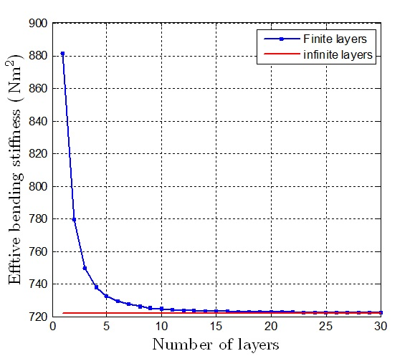

(a)

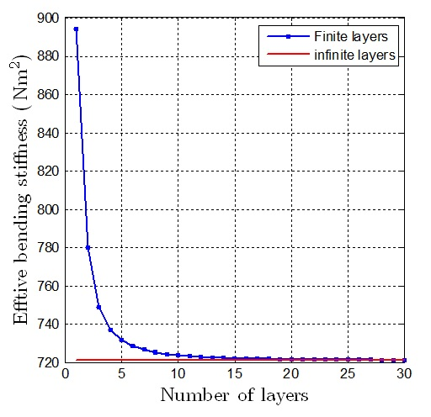 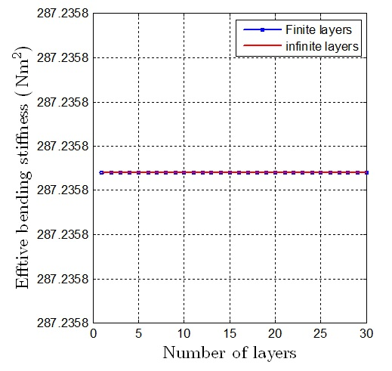

(c)

(b)

Figure 2: *EI* vs. layer numbers for (a) curvilinear orthotropic, (b) curvilinear transverse isotropic, and (c) isotropic materials with helix angle 105° in no friction case

(a)

(b)

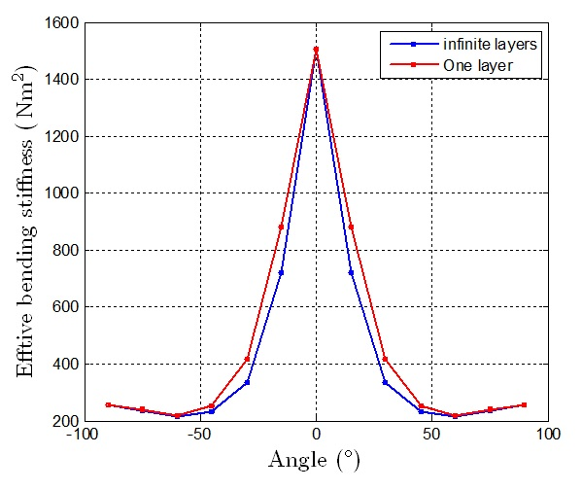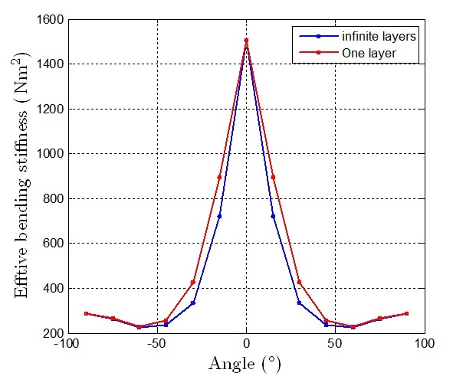

(c)

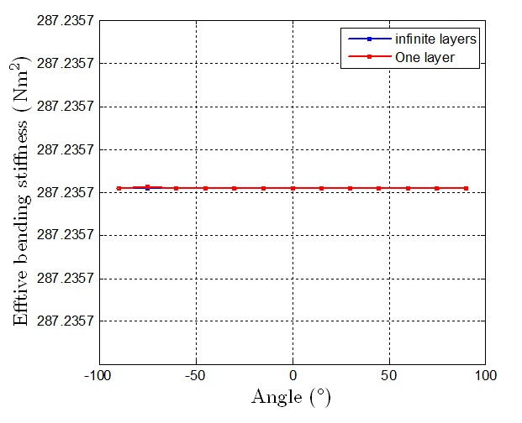

Figure 3: *EI* of cylinder with one and infinite layers vs. helix angles for (a) curvilinear orthotropic, (b) curvilinear transverse isotropic, and (c) isotropic materials in no friction cases

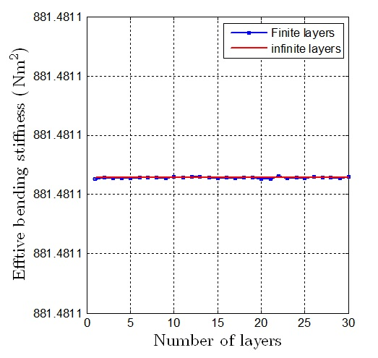

(a)

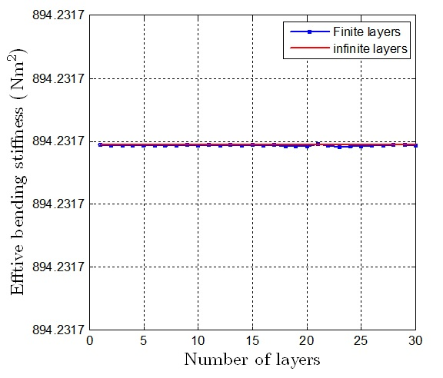 

(b)

(c)

Figure 4: *EI* vs. layer numbers for (a) curvilinear orthotropic, (b) curvilinear transverse isotropic, and (c) isotropic materials with helix angle 105° in no slip case

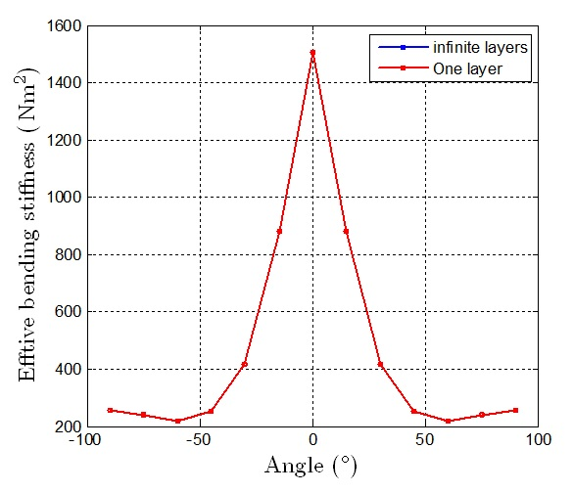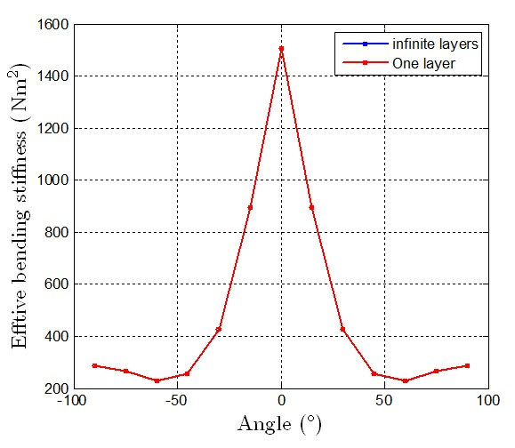

(a)

(b)



(c)

Figure 5: *EI* of cylinder with one and infinite layers vs. helix angles for (a) curvilinear orthotropic, (b) curvilinear transverse isotropic, and (c) isotropic materials in no slip cases

**Question 1: Effective bending stiffness as *N* → ∞**

**No-friction case:** The bending stiffness decreases as the number of layers increase to 30, but tend to approach to a constant as *N* increases, as shown in figure 1. So what if *N* → ∞? **Expression (15)!**

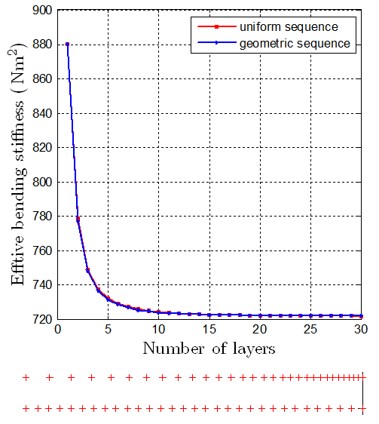

Figure 1: Effective bending stiffness vs. layer number.

Question 2: the optimization of bending stiffness

The problem is stated as following: Find the radius sequence  to maximize



where  and  are material constants,  can be solved with .

Analysis: Increasing the distance of material from the flexural center results in larger bending stiffness. So the optimal radii should be increased. The optimized sequence  would be , which means that the outset layer has largest thickness  and others are zero. To verify this idea, three different radii sequences – uniform, increasing, and decreasing – are considered. The bending stiffness is plotted in figure 2. We can see the bending stiffness with increasing sequence is larger than the other two.

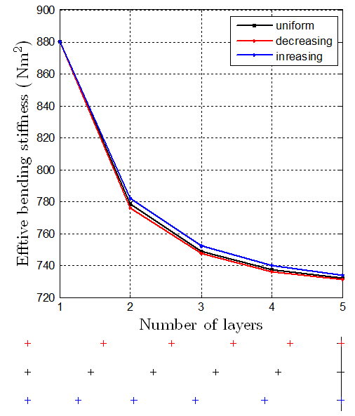

Figure 2: Bending stiffness of three radii sequences of the cylinder with five layers.